**https://www.drupal.org/node/1493366**

**Creating the View**

First, create a new view of your book content using the fields row style / unformatted list of fields (it is important that the tree style not be chosen now). No need for sorting but you can choose to output as a block.

Then:

1. Add relationship for Book: Parent
2. Add field Node ID (do not use relationship) and exclude it from display
3. Add field Node ID with relationship, exclude from display
4. Add title field (do not use relationship)
5. Change style / format plugin to Tree (Adjacency model)
6. Set Main field to Node ID
7. Set Parent field to Node ID with parent relationship

*Be aware that tree structure is not displayed in view preview.*

Finally, you can set the block to be displayed on sidebar of every book content type so you have a nice hierarchical table of content where, not bad at all, current page is highlighted.

(These instructions are taken from above example using taxonomy terms.)

**Showing just one book**

The instructions above will show all books. You can limit the view to show  
just one book, if you want.

1. Add a relationship from nodes to their book's top-level node
   * Click the Add relationship button (under Advanced settings)
   * Add the Top level book relationship:  
       
     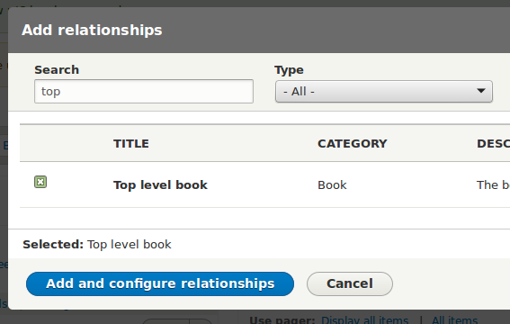
   * You don't have to change the relationship's default configuration.
2. Add a criterion using the relationship
   * Click the Add criteria button.
   * Choose the Title field from the Content category:  
       
     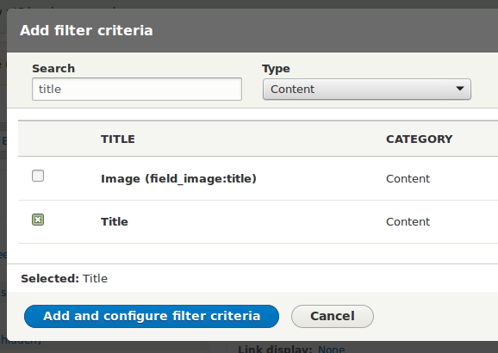
   * Configure the criterion to use your new relationship, and  
     the title of the book you want to show. That will be the  
     title of the book's root node.  
       
     